**A STR Multiplex for Columbian Black-Tailed Deer**

MaryJo Olegario, Zachary Lounsberry, Benjamin Sacks

Canid Diversity and Conservation Laboratory, Veterinary Genetics Laboratory, University of California, Davis

**INTRODUCTION**:

Noninvasive genetic sampling is a powerful approach to obtaining DNA through a variety of sources such as hair, saliva, shed skin, and feces. Throughout the nuclear genome, short tandem repeat (STR) markers are abundant and are often sufficiently polymorphic to perform individual identification, parentage, relatedness, gene mapping, and other applications (Butler 2005). Noninvasively collected samples typically yield low-quantity and highly fragmented DNA, requiring assays that make efficient use of available genetic material. Time and cost are limiting factors, which necessitates development of a multi-marker assay (“multiplex”) with all loci amplified in a single polymerase chain reaction (PCR). The multiplex assay must be composed of a suite of markers with sufficiently high polymorphism to resolve identity between different individuals, even closely related ones. Inclusion of Y-chromosome markers also can enable sex determination. We created and optimized a multiplex assay to identify individual Columbian black-tailed Deer (*Odocoileus hemionus columbianus*) from noninvasively collected DNA. This assay is to be used for genetic capture-mark–recapture studies to estimate herd sizes based on deer pellets collected along transects.

**METHODS**

Our approach was (1) use high-quality DNA extracted from deer tissue to screen markers for polymorphism, (2) design the multiplex, (3) conduct efficacy tests on DNA diluted to a range of known concentrations, (3) test the multiplex on DNA derived from scat, and (4) quantify genotyping error and assay performance.

**RESULTS**

**Multiplex panel design**

We initially screened 24 microsatellite primer pairs originally developed for cattle, domestic sheep, deer (*Odocoileus* spp.) or other cervids. From these, we selected 10 loci and a sex marker based on successful amplification, size distribution of the alleles, polymorphism, and primer compatibility based on predictions of the Autodimer program through the STRBase website ([Ruitberg 2001)](http://www.cstl.nist.gov/biotech/strbase). Fluorescent tags were added to the 5’ ends of the forward primers in order to distinguish between any overlap between the microsatellite loci and the sex marker incorporated into the final multiplex panel (Figure. 1). These polymorphic loci ranged from 2 (ADCYC) to 12 (SBTD04 & ETH152) alleles per locus.

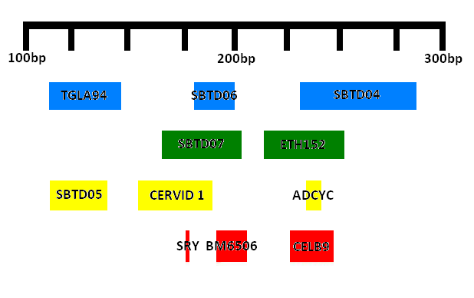

Figure 1. Fluorescent dye label colors - blue, (FAM), green (VIC), red (PET), and yellow (NED), relative to PCR product size ranges.

DNA samples were amplified using a Qiagen Multiplex PCR Kit. Products were electrophoretically separated using an ABI 3730 Genetic Analyzer and analyzed using the software STRand (Veterinary Genetics Laboratory, UC Davis) to determine genotypes (Figure 2). Allele sizes are called relative to the Genescan 500-LIZ size standard that is incorporated into the genotyping process.

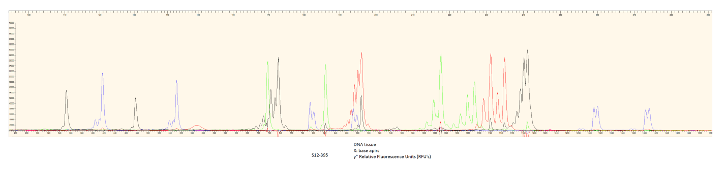,

Figure 2. Electropherogram of the multiplex for Columbian black-tailed deer.  The X-axis measures the allele size in base pairs. The Y-axis measures the intensity of fluorescent peaks in relative fluorescent units.

**Multiplex Optimization**

* Sample Quantification
  + Scat, tissue, buccal cells
* Efficacy test
* Qiagen multiplex PCR Kit + Q solution
* Adjust primer concentration
  + ranging from .08 to 0.55uM

**Multiplex Panel Performance Evaluation:**

Tissue and scat DNA samples were quantified using real-time qPCR (Lindquist et al. YEAR). In a prototypic multiplex, we saw that majority of the scat samples were amplifying at >8 loci at concentrations greater than 200pg/ul (Figure 5).

Figure 5. Frequency of loci amplified in 60 deer scat DNA samples as a function of DNA concentration

When testing the sensitivity of the final multiplex at the lower end of the spectrum, full genotyping profiles were obtainable with DNA concentrations as low as 100 pg/ul of high quality DNA. The multiplex was aimed to target 60-85% of the concentrations found within deer fecal DNA samples. Various pellet samples will perform differently even if DNA concentrations are high, due to inhibition within the sample.

We chose to examine the lower spectrum of the scat DNA samples. DNA samples from 4 individuals were serially diluted to concentrations of 100, 50, 25 and 10 pg/ul (Figure 6).

Figure 6. Multiplex sensitivity; average number of loci amplified in 4 individual deer samples.

The sex marker (SRY) was still detectable at concentrations as low as 10pg and was not among the first loci to drop out in our sensitivity studies. This marker was able to correctly distinguish between all known male and female individuals (Figure 7). Depending on the sex ratio, including the SRY sex marker would increase the discriminatory power of this multiplex panel up to 2x (Brinkman et al 2010).

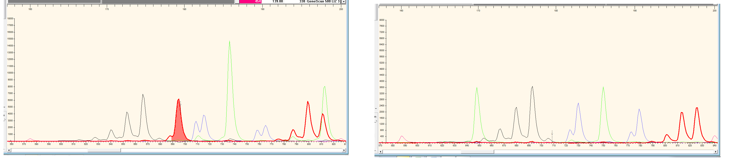

Figure 7. SRY amplification in male (left) and female (right) deer.

**Genetic Diversity and Genotyping Error Rates:**

Scat samples (*n* = 47) were replicated 4x to assess genotyping error rates for each microsatellite locus. Based on the consensus genotypes, errors attributed to false alleles (FA) or allelic dropouts (ADO) were computed. Genetic diversity and probability of identity of the microsatellite DNA loci were evaluated using 32 individuals (25 F, 7 M). With the HW P(ID) being 3E-11, and more conservatively, the P(ID)Sibs values being 0.0001, this assay can be used to identify individuals with high confidence. Generally, P(ID)Sibs values between 0.001-0.0001 are sufficiently low and can be applied to forensic applications in natural populations (Waits et at 2001). Examination of pairwise linkage disequilibrium revealed that all ten microsatellite loci were in linkage equilibrium after applying the sequential Bonferroni test (Rice 1989). All loci were found to be in Hardy-Weinberg Equilibrium with the exception of CERVID1 and SBTD05. These highly polymorphic loci can be used to distinguish between even closely related deer in the population.



**Table 1.** Characteristics of the 10 microsatellite markers used for individual identification of Columbian black-tailed deer.

Taking into account genotyping error rates, at least 3 replications at each locus is necessary to accurately identify a consensus genotype without having the same individual falsely considered to be two distinct individuals (Figure 7). At 3 or more replications, there is virtually a 0% chance of incorrectly genotyping an individual. Although several genotyping errors occurred, the overall rate is still low and well suited for individual identification.

**Figure 7.** Frequency of incorrectly genotyping scat DNA as a function of PCR replications.

**CONCLUSION:**

This 5 dye STR multiplex system is to be used for individualizing Columbian black-tailed deer. This multiplex was designed to fit 10 polymorphic markers and a sex marker in a single reaction tube. Primer pairs successfully produced amplicons ranging from 100 – 300 base pairs in length and the sex marker was able to correctly identify male and female individuals. This suite of microsatellite markers are sufficient to differentiate between closely related individuals, enabling use in genetic mark-recapture estimation of population abundance. This assay would serve as an important tool for monitoring ungulate populations where obtaining population sizes through direct observation is challenging. Moreover, the use of a standard panel to genotype deer throughout the state will provide reference population data that can be used in assignment analyses to determine geographic origins of particular deer in other forensic investigations.

**Acknowledgements:** We would like to thank the UC Davis Forensic Sciences Graduate Program and Veterinary Genetics Laboratory for funding for this project. We would also like to thank Tavis Forrester and Heiko Wittmer for donating deer samples.

**LITERATURE CITED**

**FIX!**

e PCR assays. J Forensic Sci 56(1):S29–S35  
±**Moore,S .**S., and K. Bryne, 1993. Dinucleotide polymorphism at the bovine calmodulin independent adenylcyclase locus. Anim. Genet. 24: 150.

**Park, S. D. E**. 2001. The Excel Microsatellite Toolkit (version 3.1). Animal Genomics Laboratory, UCD, Ireland. http://animalgenomics.ucd.ie/sdepark/ms-toolkit/

**Ruitberg, C.,** Reeder, D., and Butler, J. (2001) STRBase: a short tandem repeat DNA database for the human identity testing community.Nucleic Acids Research. 29(1): 320-322

"**Steffen, P.,** Eggen, A., Dietz, A.B., Womack, J.E., Stranzinger, G. and Fries,R (1993). Isolation and mapping of polymorphic microsatellites in cattle. Animal Genetics 24(2) pp121-124.

^**Tate, M. L**., et al. (1992). The use of protein polymorphism and DNA fingerprinting to solve complex pedigree problems in deer. Proceedings of the New Zealand Society of Animal Production 52:143–144.

**Waits L.P**., Luikart G., Taberlet P. 2001. Estimating the probability of identity among genotypes in natural populations: cautions and guidelines. Molecular Ecology, 10, 249 – 256.

**Wilberg** MJ, Dreher BP (2004) GENECAP: a program for analysis of multilocus genotype data for non-invasive sampling and capture-recapture population estimation. Molecular Ecology Notes, 4, 783–785.

**-Wilson P.J**., White BN. Sex Identification of Elk (Cervus elaphus canadensis), Moose (Alces alces), and White-Tailed Deer (Odocoileus virginianus) Using the Polymerase Chain Reaction J Forensic Sci 1998;43(3):477–482.